Final Project Report
Name: Kadiatou Diallo
Prof: Yanilda
Date: 5/6/2026
Class: CIS344

Title: Real Estate Agency Portal

1. Introduction
The purpose of this project is to develop a web-based Real Estate Agency Portal using PHP and MySQL. The platform simulates a real-world real estate system where agents, buyers, and renters interact with property listings.
The system allows:
- Agents to add and manage property listings
- Buyers and renters to browse available properties
- Users submit inquiries and save favorite properties
- The system to track transactions such as property sales and rentals
This project demonstrates the integration of frontend PHP pages with a backend MySQL database, along with authentication, session management, and role-based access control.

2. Database Design
The database used in this project is named: real_estate_portal_db
It consists of five main tables:

Users Table: This table stores all registered users of the system.
userId: Primary key
userName: Unique username
passwordHash: Encrypted password
userType: Defines role (agent, buyer, renter)
The purpose of this table is to store all real estate listings

Inquiries Table
This table stores messages from buyers or renters about properties.
inquiryId: Primary key, userId: Foreign key, propertyId: Foreign key, and message, inquiryDate
The purpose of this table is to track user interest in properties

Transactions Table
This table records completed property sales or rentals.
transactionId: Primary key
transactionType: sale or rental
amount, transactionDate
The purpose of this table is to maintain financial and transaction records

Favorites Table
This table stores saved properties for buyers and renters.
- favoriteId: Primary key
- userId, propertyId
The purpose of this table allows users to bookmark properties

Relationships
- One agent can manage multiple properties
- One user can submit multiple inquiries
- One property can have multiple inquiries
- Transactions link users and properties

View: PropertyListingView
- This view combines property and agent information to display listings in a user-friendly format.

Stored Procedures
- AddOrUpdateUser: Inserts or updates user records
- ProcessTransaction: Inserts transaction and updates property status

Trigger
- AfterTransactionInsert automatically updates property status when a transaction occurs

3. PHP Functionality
The application uses PHP with PDO for database interaction.

addUser()
- Insert a new user into the Users table
- Uses prepared statements for security

addProperty ()
- Allows agents to add new property listings
- Stores property details in the database

addInquiry ()
- Allows buyers/renters to submit messages about a property

getUserDetails ()
- Retrieves user data from the database
- Can be extended to include related records

Other Functionalities
- Viewing properties using PropertyListingView
- Saving favorites
- Managing sessions and dashboards
4. Login and session handling
The system implements secure authentication using PHP built-in functions.

Password Hashing
Passwords are securely stored using password_hash ($password, PASSWORD_DEFAULT);

Password Verification
During login: password_verify ($password, $hashedPassword);

Session Management
- PHP sessions are used to track logged-in users
- Session variables: userId, role
This helps Secure login handling, Persistent user sessions, Protection against unauthorized access.

5. Role-Based Access Control
The system supports three roles:

Agent: Add and manage properties, View listings

Buyer: Browse properties, submit inquiries, Save favorites

Renter: Same permissions as buyers but focused on rentals

Access is restricted by using role checks such as: requireRole(['agent']);
This ensures users can only access features relevant to their role.

6. Challenges and Solution

1. Login Issues
Problem: Users could not log in due to incorrect password comparison
Solution: Used password_verify () instead of plain text comparison

2. Foreign Key Errors
Problem: Inserting records failed due to missing referenced IDs
Solution: Ensured users and properties exist before inserting dependent data

3. Session Handling
Problem: Sessions were not persisting across pages
Solution: Added session_start() at the top of every protected page
4. Role Restrictions
Problem: Users could access unauthorized pages
Solution: Implemented a requireRole () function

7. Screenshots
The following screenshots demonstrate the working system:
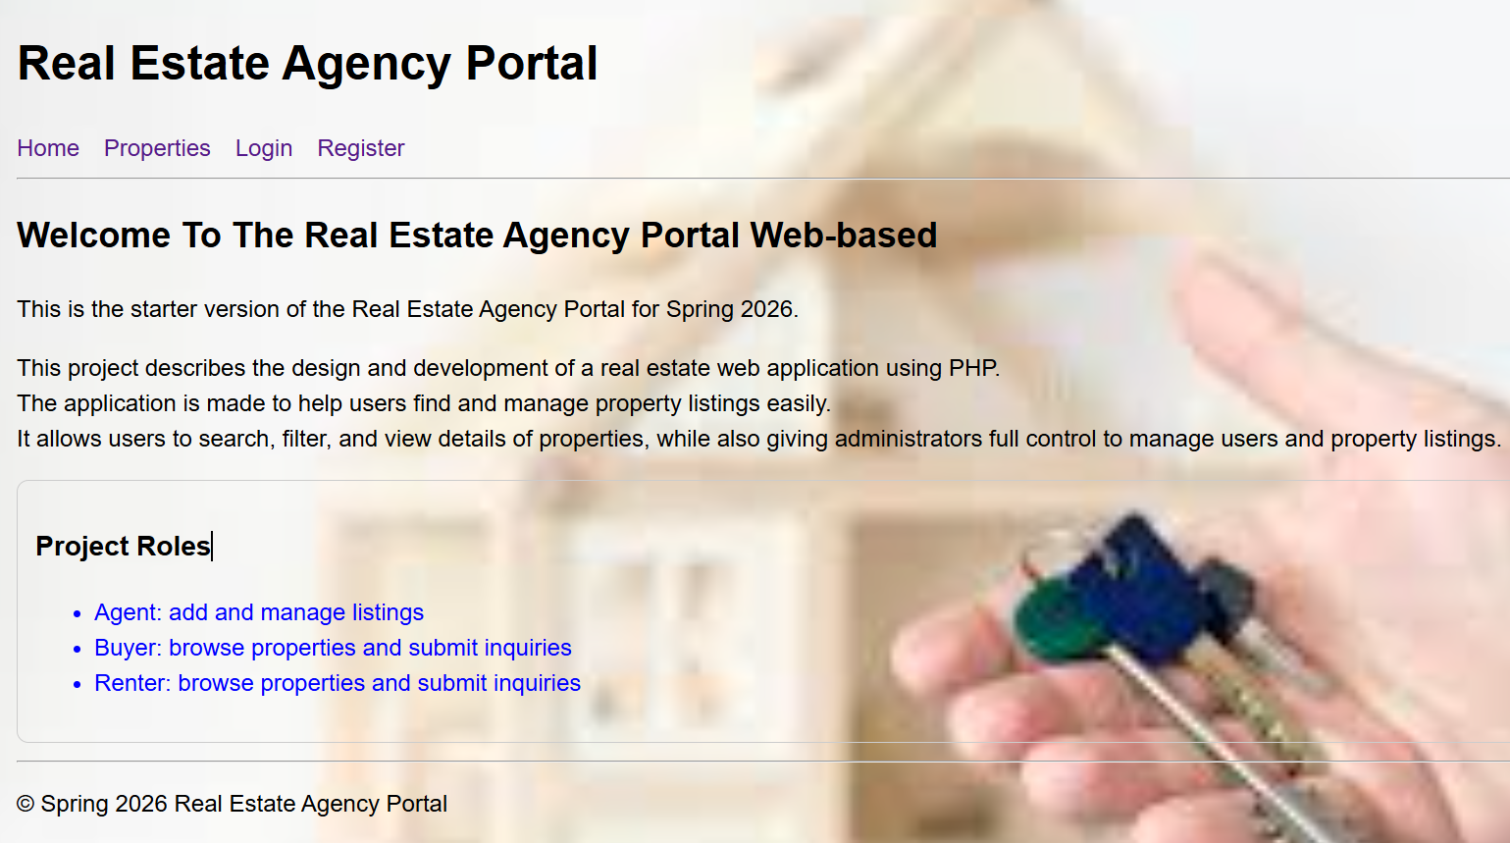
Register
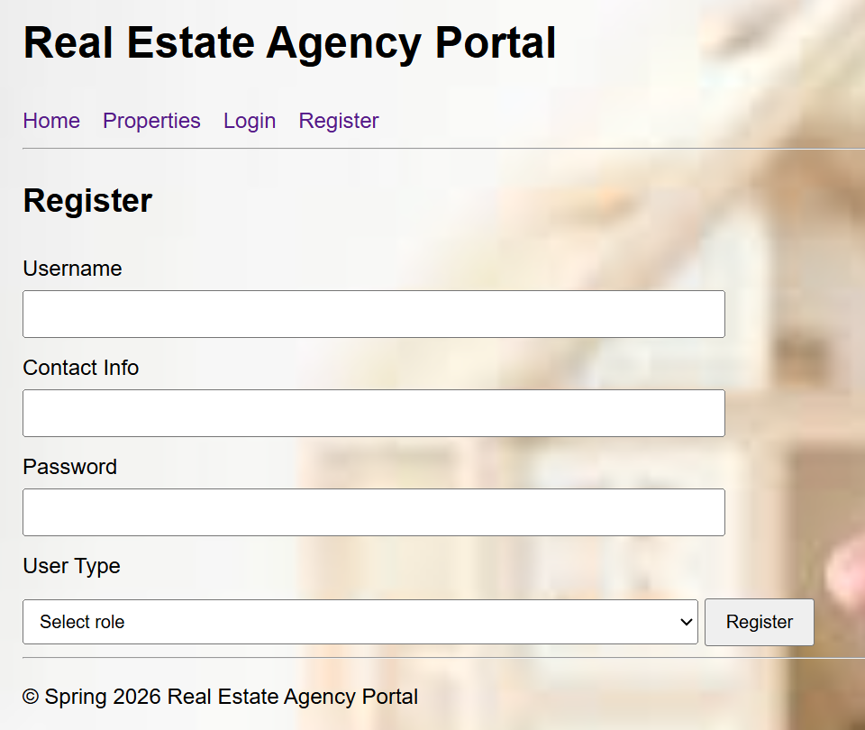
Login Page
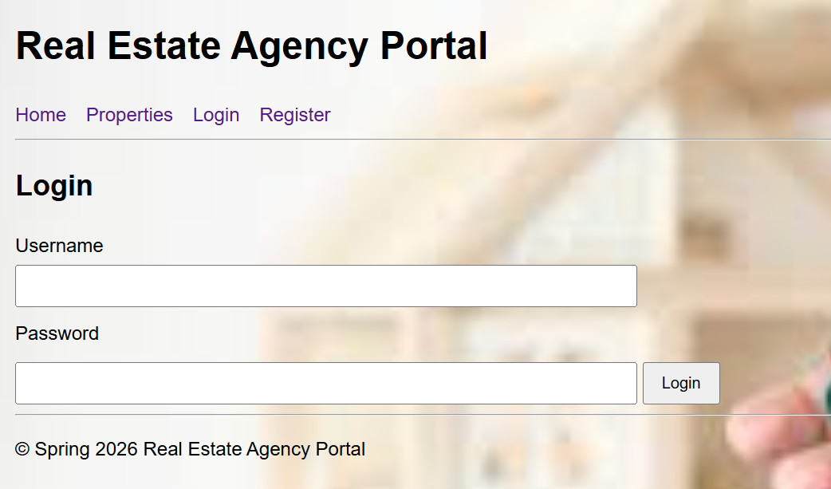
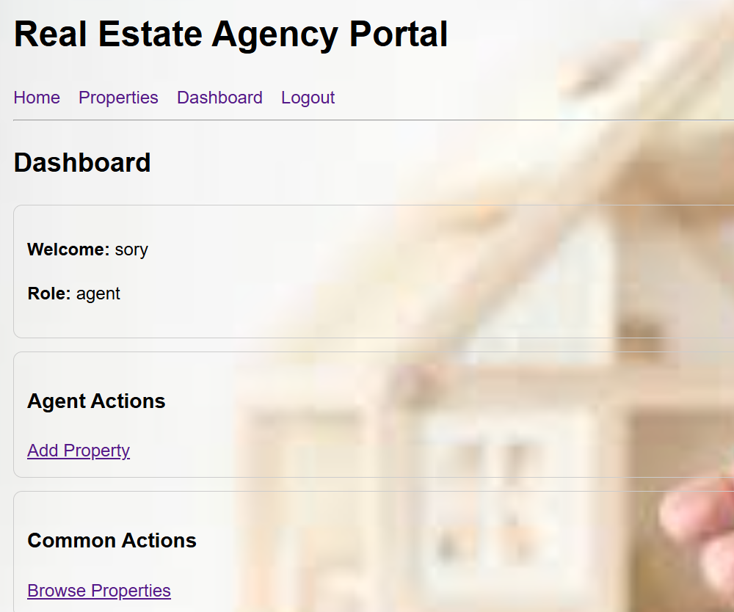
Add Property Page

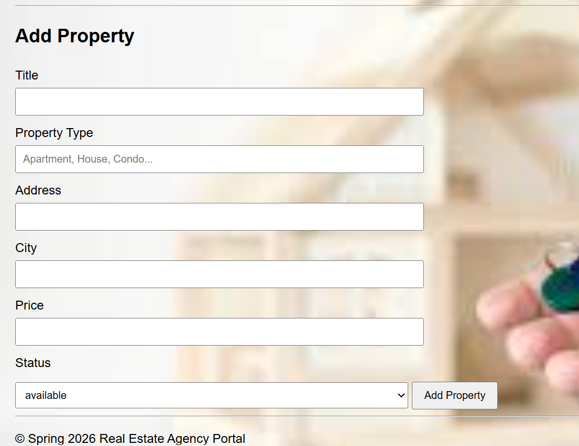
- Property Listing Page
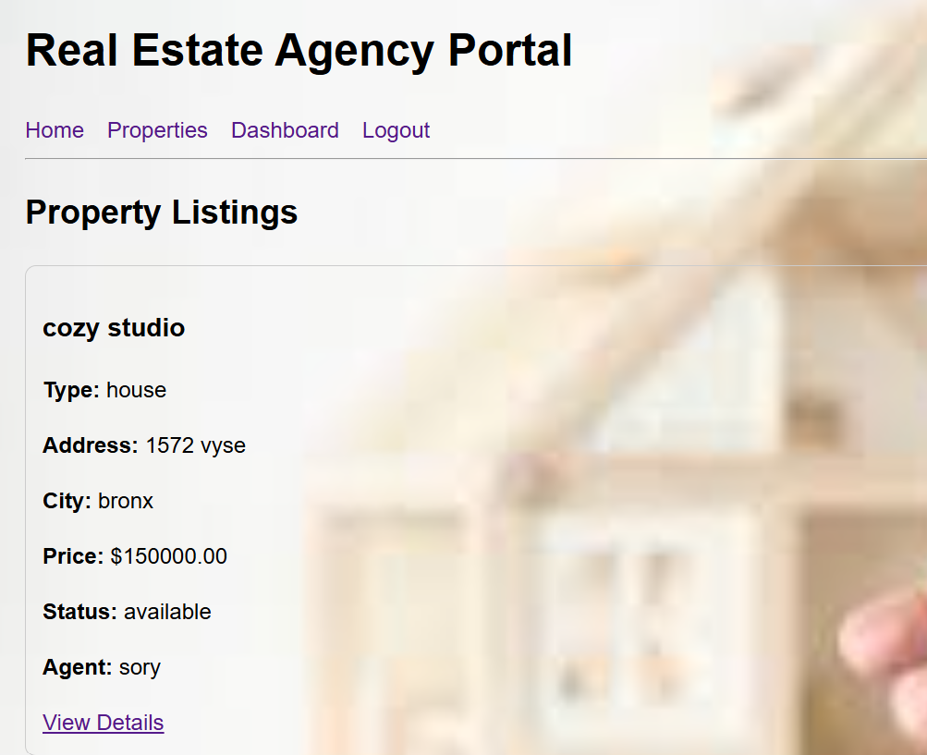

Inquiry Submission Page
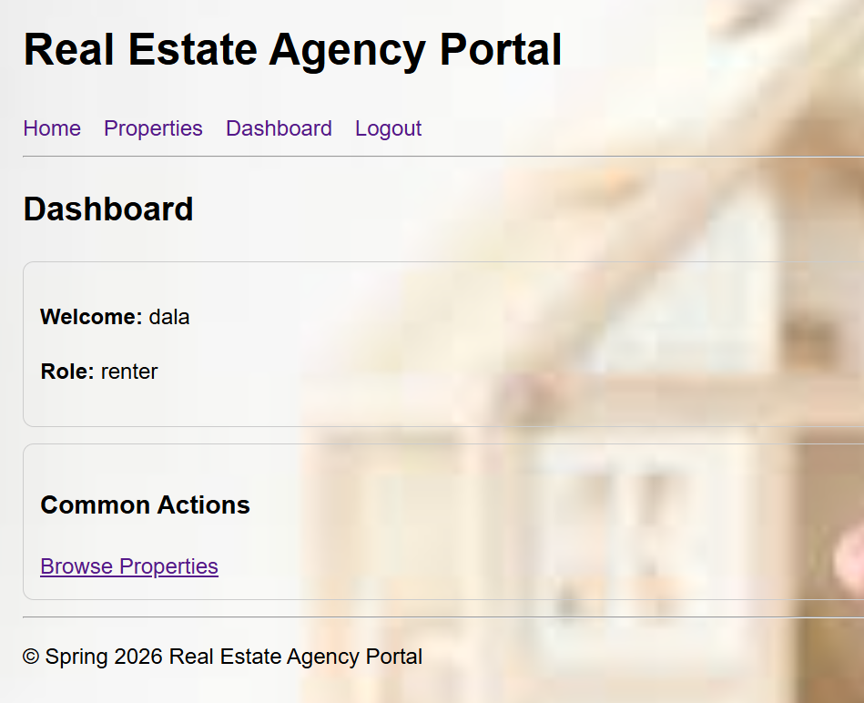
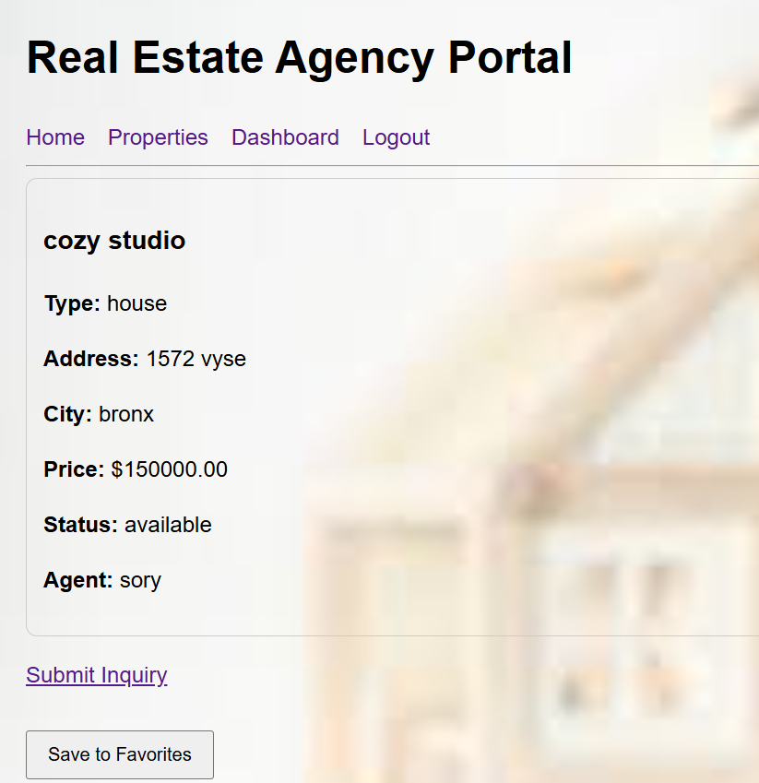
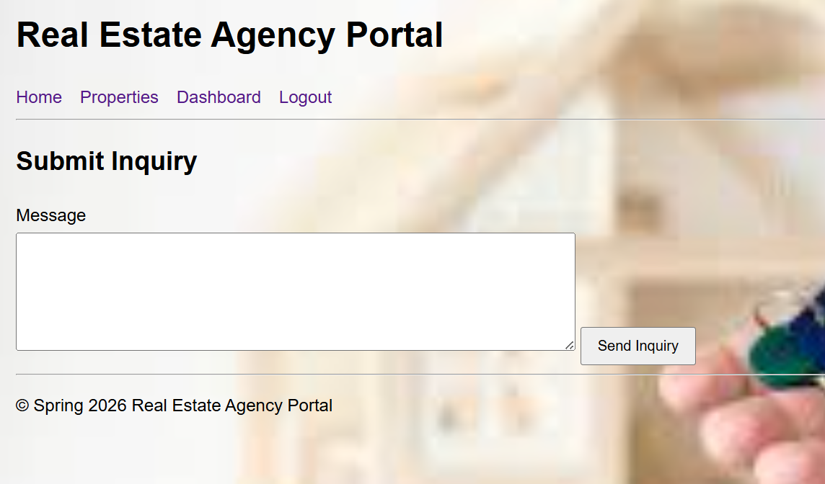
Database Tables (phpMyAdmin)
Users table
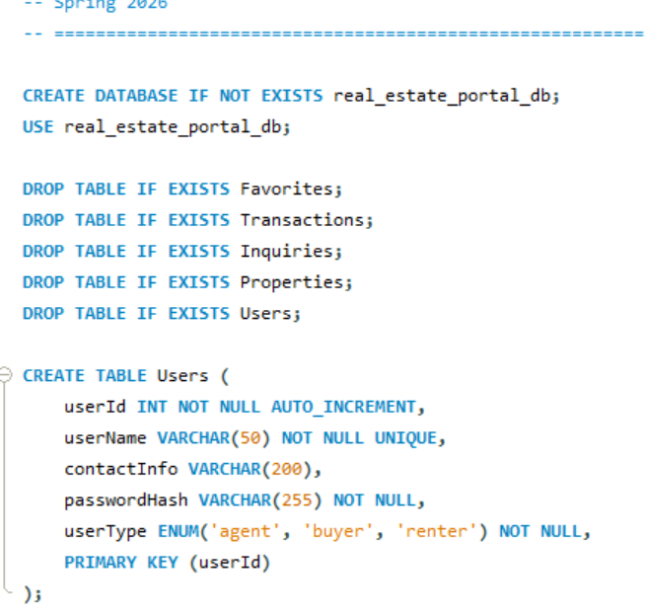
Properties table
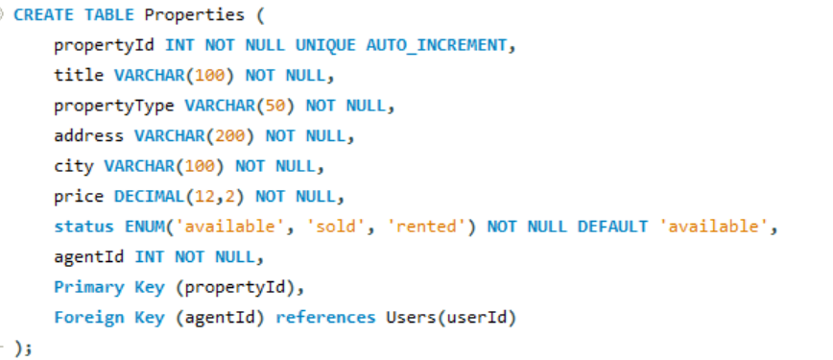
Inquiries table
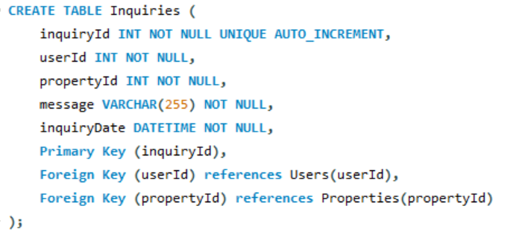
Transaction table
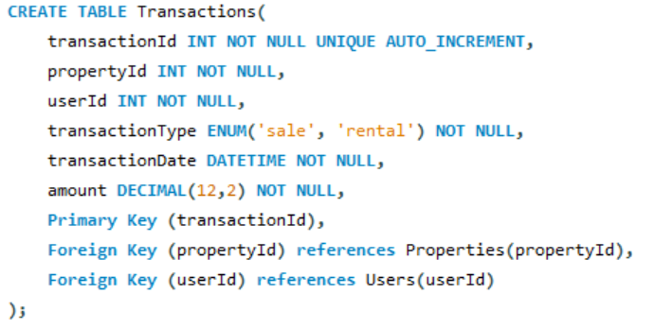
Favorites table
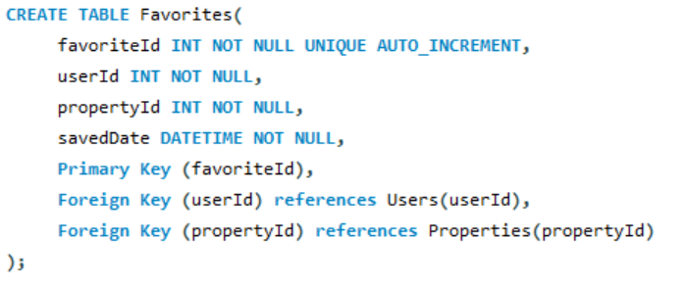
Procedure
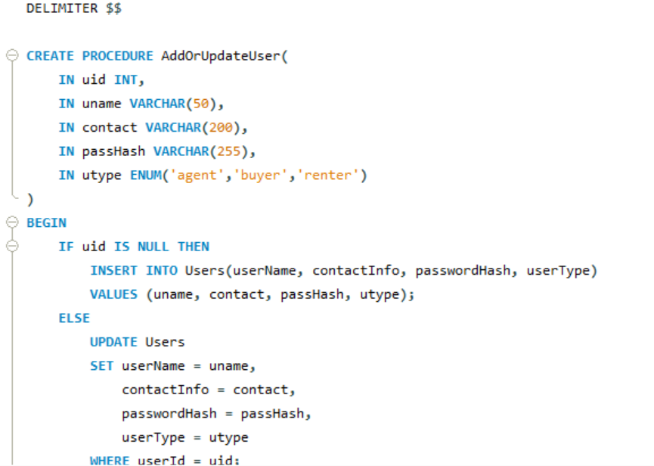
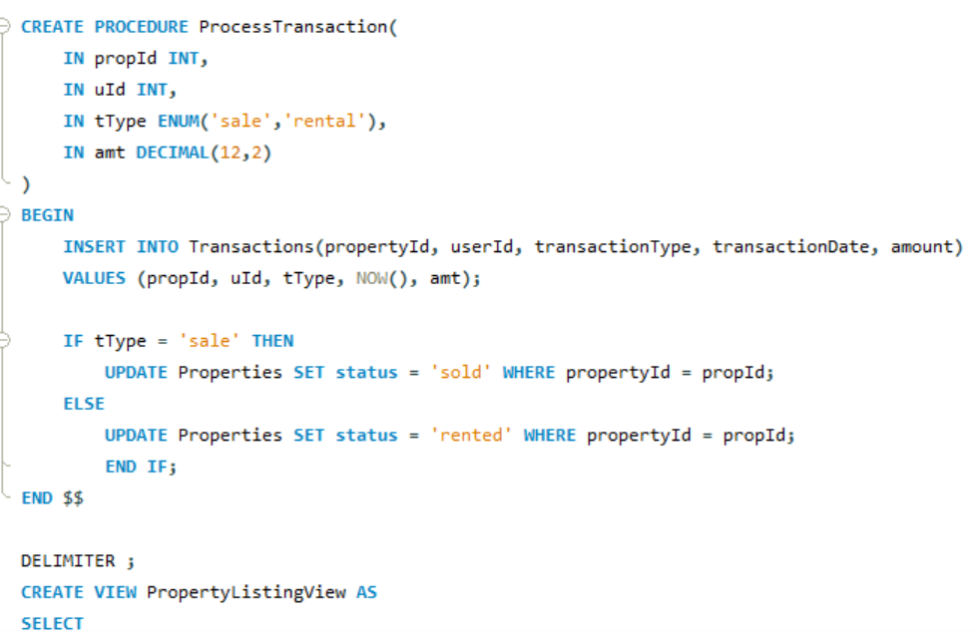
View
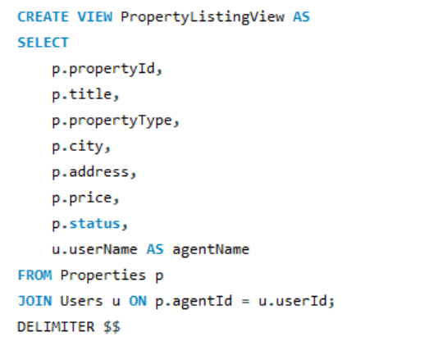
Trigger
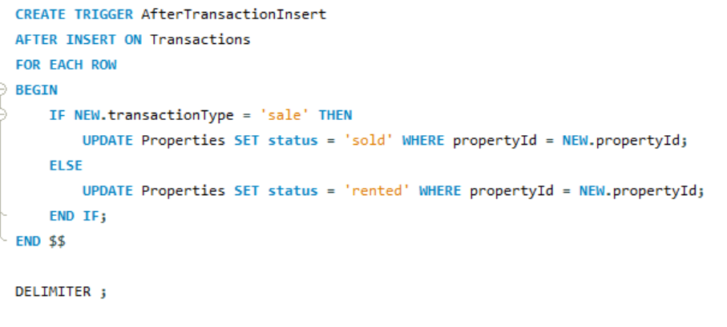

Conclusion
This project successfully demonstrates the development of a full-stack real estate portal using PHP and MySQL. It integrates database design, backend logic, authentication, and role-based access control into a functional system. The platform reflects real-world application behavior and provides a strong foundation for further enhancements such as search features, image uploads, and admin dashboards.

